**МИНОБРНАУКИ РОССИИ**

**Санкт-Петербургский государственный**

**электротехнический университет**

**«ЛЭТИ» им. В.И. Ульянова (Ленина)**

**Кафедра МО ЭВМ**

отчет

**по лабораторной работе №3**

**по дисциплине «Теория игр и исследование операций»**

Тема: Релаксация линейного программирования.

|  |  |  |
| --- | --- | --- |
| Студент гр. 5381 |  | Кобылянский А.В. |
| Преподаватель |  | Шолохов А.В. |

Санкт-Петербург

2018

Задание 1. Сегментация изображения.

Код для решения задачи:

|  |
| --- |
| **import** numpy **as** np  **from** pystruct.inference **import** inference_dispatch  **from** pystruct.utils **import** make_grid_edges  **from** scipy.io **import** loadmat  **import** matplotlib.pyplot **as** plt  **def** task1():  data = loadmat(**'data/mrf_potentials_segmentation.mat'**)  unary_potentials = data.get(**'unary_potentials'**) *# type: np.ndarray (338, 430, 3)*  pairwise_potentials_vert = data.get(**'pairwise_potentials_vert'**) *# type: np.ndarray (3, 3)*  pairwise_potentials_horz = data.get(**'pairwise_potentials_horz'**) *# type: np.ndarray (3, 3)*    edges = make_grid_edges(unary_potentials) *# (289912, 2)*  height, width, n_states = unary_potentials.shape  n_edges = edges.shape[0]  pairwise_potentials = np.zeros(shape=(n_edges, n_states, n_states))  **for** i, edge **in** enumerate(edges):  vert_1, vert_2 = edge  y1, x1 = divmod(vert_1, width)  y2, x2 = divmod(vert_2, width)    **if** abs(y1 - y2) == 1:  *# vertical edge*  pairwise_potentials[i, :, :] = pairwise_potentials_vert  **elif** abs(x1 - x2) == 1:  *# horisontal edge*  pairwise_potentials[i, :, :] = pairwise_potentials_horz    *# QPBO because max-product works slow.*  result = inference_dispatch(-1.0*unary_potentials, -1.0*pairwise_potentials, edges, inference_method=**'qpbo'**)    picture = result.reshape(height, width)  plt.imshow(picture, vmin=0, vmax=n_states, cmap=**'gray'**)  plt.show()  **if** __name__ == **'__main__'**:  task1() |

Результат:

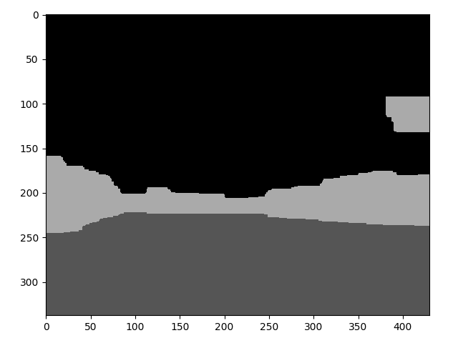Результат работы программы с использование только унарных потенциалов (*inference_method*=“*unary*” в функции *inference_dispatch*).

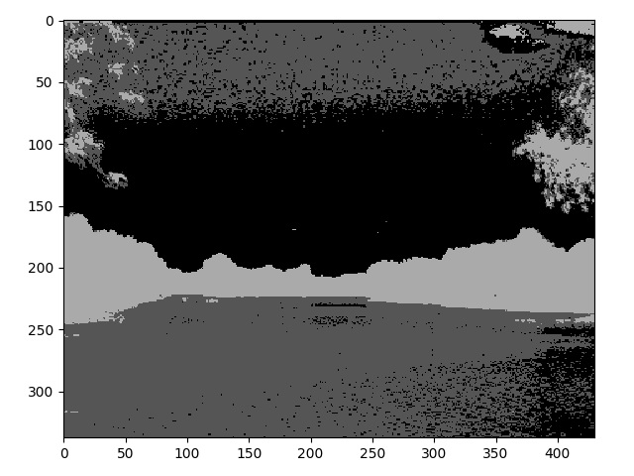

Задание 2. Склеивание изображений.

Код программы:

|  |
| --- |
| **import** imageio  **import** matplotlib.pyplot **as** plt  **import** numpy **as** np  **import** visvis **as** vv  **from** numpy.linalg **import** norm  **from** pystruct.inference **import** inference_dispatch  **from** pystruct.utils **import** make_grid_edges  **class** ImagesData:  **def** __init__(self, images_names, markup_name=**None**):  self.shape = **None**  self.images = []  self.markup = **None**  self.__load_images(images_names)  **if** markup_name **is not None**:  self.__load_markup(markup_name)  **def** __check_shape(self, image):  **if** self.shape **is None**:  self.shape = image.shape  **else**:  **if** self.shape != image.shape:  print(**'images shapes are not equile'**)  print(self.shape, image.shape)  exit(1)  **def** __load_images(self, images_names):  self.images = []  **for** image_name **in** images_names:  self.images.append(imageio.imread(image_name))  self.__check_shape(self.images[-1])  **def** __load_markup(self, markup_name):  self.markup = imageio.imread(markup_name) // 20  self.__check_shape(self.markup)  **def** __scale_image(self, image, scale):  height, width, colors = self.shape  new_height, new_width = height // scale, width // scale  new_image = np.zeros(shape=(new_height, new_width, colors))  **for** x **in** range(new_width):  **for** y **in** range(new_height):  square = image[scale * y:scale * (y + 1), scale * x:scale * (x + 1)]  new_image[y, x] = np.rint(np.mean(square, axis=(0, 1)))  **return** new_image  **def** __scale_markup(self, markup, scale):  height, width, colors = self.shape  new_height, new_width = height // scale, width // scale  new_markup = np.zeros(shape=(new_height, new_width, colors))  n_states = len(self.images)  **for** x **in** range(new_width):  **for** y **in** range(new_height):  value = 0  count = 0  **for** i **in** range(scale * x, scale * (x + 1)):  **for** j **in** range(scale * y, scale * (y + 1)):  **if** markup[j, i, 0] < n_states:  value = markup[j, i, 0]  count += 1  **if** count >= scale ** 2 / 2:  new_markup[y, x] = np.array([value, value, value])  **else**:  new_markup[y, x] = np.array([255 // 20, 255 // 20, 255 // 20])  **return** new_markup  **def** scale(self, scale: int):  *# scale images and markup to 1/scale times*  *# each new pixel is mean of scale x scale square in origin image*  self.images = [self.__scale_image(image, scale) **for** image **in** self.images]  **if** self.markup **is not None**:  self.markup = self.__scale_markup(self.markup, scale)  height, width, colors = self.shape  self.shape = (height // scale, width // scale, colors)  **class** Task2:  **def** __init__(self, images_data: ImagesData, unary_potentials):  self.imgs = images_data  self.unary_potentials = unary_potentials  self.__result = **None**  self.path_to_dump_file = **None**  self.diff_function = diff_standart  **def** __compute_pairwise_potentials(self, edges):  n_states = len(self.imgs.images)  n_edges = edges.shape[0] *# 849946*  height, width, _ = self.imgs.shape  pairwise_potentials = np.zeros(shape=(n_edges, n_states, n_states))    **for** i, edge **in** enumerate(edges):  **if** i % 1000 == 0:  print(**'{} / {}'**.format(i // 1000, len(edges) // 1000))  vert_1, vert_2 = edge  y1, x1 = divmod(vert_1, width)  y2, x2 = divmod(vert_2, width)  **for** state_1 **in** range(n_states):  **for** state_2 **in** range(n_states):  **if** state_1 != state_2:  pairwise_potentials[i, state_1, state_2] = self.diff_function(self.imgs.images, state_1,  state_2, x1, y1, x2, y2)  **return** pairwise_potentials  **def** __load_pairwise_potentials(self, path):  n_states = len(self.imgs.images)  res = np.fromfile(path)  elements_count = res.shape[0]  **return** res.reshape((elements_count // n_states ** 2, n_states, n_states))  **def** __get_regions(self):  **if** self.__result **is not None**:  height, width, _ = self.imgs.shape  **return** self.__result.reshape(height, width)  **def** set_dump_file(self, path_to_dump_file: str):  self.path_to_dump_file = path_to_dump_file  **def** set_diff_function(self, diff_function):  self.diff_function = diff_function  **def** draw_regions(self):  **if** self.__result **is not None**:  regions = self.__get_regions()  n_states = len(self.imgs.images)  plt.imshow(regions, vmin=0, vmax=n_states)  plt.show()  **def** draw_picture(self):  **if** self.__result **is not None**:  regions = self.__get_regions()  height, width = regions.shape  picture = np.zeros(shape=(height, width, 3))  **for** x **in** range(width):  **for** y **in** range(height):  region = regions[y, x]  picture[y, x] = self.imgs.images[region][y, x]  vv.imshow(picture)  **def** get_pairwise_potentials(self, edges, from_file, save_to_file):  **if** (from_file **or** save_to_file) **and** self.path_to_dump_file **is None**:  **raise** Exception(**'Path to dump file is not set'**)  **if** from_file:  pairwise_potentials = self.__load_pairwise_potentials(self.path_to_dump_file)  **else**:  pairwise_potentials = self.__compute_pairwise_potentials(edges)  **if** save_to_file:  pairwise_potentials.tofile(self.path_to_dump_file)  **return** pairwise_potentials  **def** compute(self, eta, from_file=**True**, save_to_file=**False**):  unary_potentials = self.unary_potentials  edges = make_grid_edges(unary_potentials)  pairwise_potentials = self.get_pairwise_potentials(edges, from_file, save_to_file)  print(**'start computing'**)  self.__result = inference_dispatch(-unary_potentials, -eta * pairwise_potentials, edges,  inference_method=**'qpbo'**)  print(**'stop comuting'**)  **def** diff_standart(images, state_1, state_2, x1, y1, x2, y2):  d1 = images[state_1][y1, x1] - images[state_2][y1, x1]  d2 = images[state_1][y2, x2] - images[state_2][y2, x2]  **return** norm(d1) + norm(d2)  **def** diff_alternative(images, state_1, state_2, x1, y1, x2, y2):  d1 = images[state_1][y1, x1] - images[state_2][y1, x1]  d2 = images[state_1][y2, x2] - images[state_2][y2, x2]  d3 = images[state_1][y1, x1] - images[state_1][y2, x2]  d4 = images[state_2][y1, x1] - images[state_2][y2, x2]  **return** (norm(d1) + norm(d2)) / (norm(d3) + norm(d4) + 1)  **def** compute_unary_potentials_family(images_data: ImagesData):  INF = 10 ** 5  height, width, _ = images_data.shape  n_states = len(images_data.images)  markup = images_data.markup  unary_potentials = np.zeros(shape=(height, width, n_states))  **for** y **in** range(height):  **for** x **in** range(width):  **if** markup[y, x, 0] < n_states:  **for** state **in** range(n_states):  **if** state != markup[y, x, 0]:  unary_potentials[y, x, state] = INF  **return** unary_potentials  **def** compute_unary_potentials_pano(images_data: ImagesData):  INF = 10 ** 5  height, width, _ = images_data.shape  n_states = len(images_data.images)  unary_potentials = np.zeros(shape=(height, width, n_states))  **for** y **in** range(height):  **for** x **in** range(width):  **for** state, image **in** enumerate(images_data.images):  **if** np.all(image[y, x] == 0):  unary_potentials[y, x, state] = INF  **return** unary_potentials  **def** task2_family():  images_names = [  **'data/family/small_DSC_0168.png'**,  **'data/family/small_DSC_0170.png'**,  **'data/family/small_DSC_0173.png'**,  **'data/family/small_DSC_0174.png'**,  **'data/family/small_DSC_0176.png'**,  ]  markup_name = **'data/family/familydatacost.png'**  images_data = ImagesData(images_names, markup_name)  images_data.scale(2)  unary_potentials = compute_unary_potentials_family(images_data)  task2 = Task2(images_data, unary_potentials)  task2.set_dump_file(**'data/family_dump'**)  task2.compute(eta=0.5, from_file=**False**, save_to_file=**True**)  task2.draw_regions()  task2.draw_picture()  input(**'Press any key'**)  **def** task2_pano():  images_names = [  **'data/pano/NQIMG_0257.PNG'**,  **'data/pano/NQIMG_0258.PNG'**,  **'data/pano/NQIMG_0259.PNG'**,  **'data/pano/NQIMG_0260.PNG'**,  **'data/pano/NQIMG_0261.PNG'**,  **'data/pano/NQIMG_0263.PNG'**,  **'data/pano/NQIMG_0264.PNG'**,  ]  images_data = ImagesData(images_names)  images_data.scale(4)  unary_potentials = compute_unary_potentials_pano(images_data)  task2 = Task2(images_data, unary_potentials)  task2.set_dump_file(**'data/pano_dump2'**)  task2.set_diff_function(diff_alternative)  task2.compute(eta=0.5, from_file=**False**, save_to_file=**True**)  task2.draw_regions()  task2.draw_picture()  *# input('Press any key')*  **if** __name__ == **'__main__'**:  *# task2_family()*  task2_pano() |

Семья.

При различных разбиения различаются, но картинка всегда почти одинаковая, без особых артифактов. Приведуем рещультат для

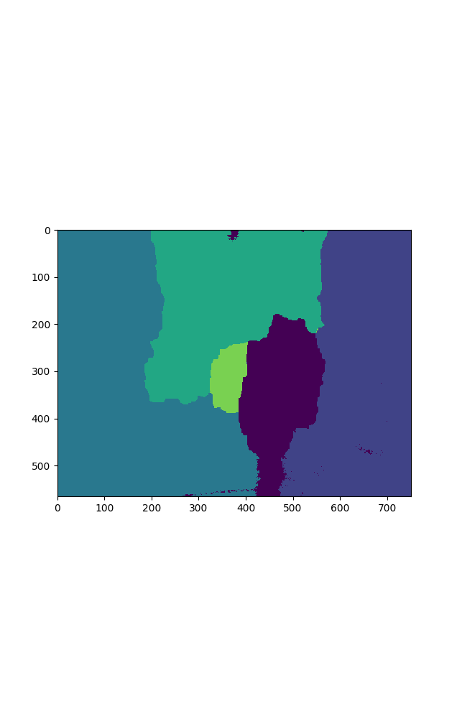Разбиение:

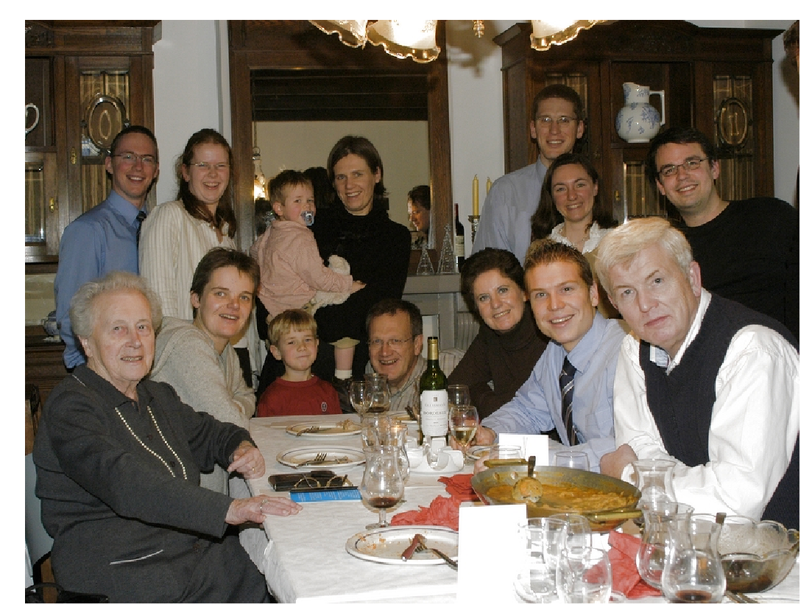Результат:

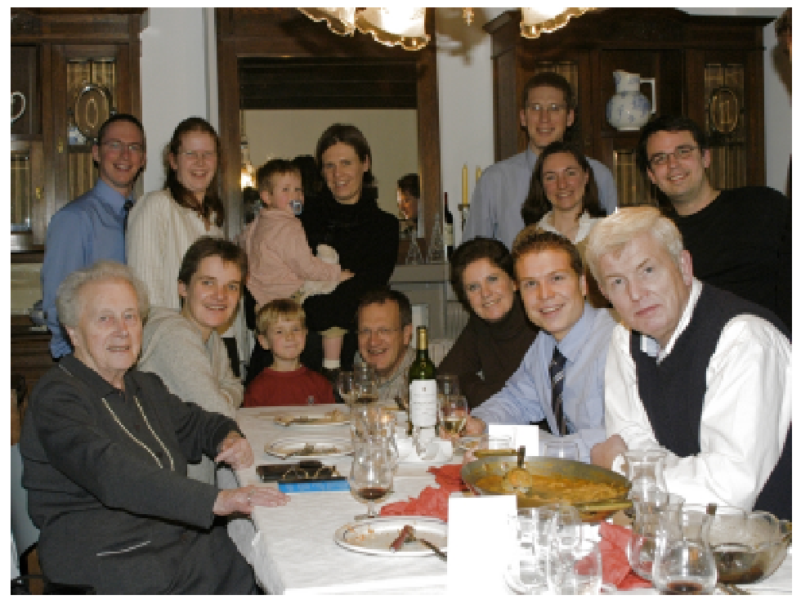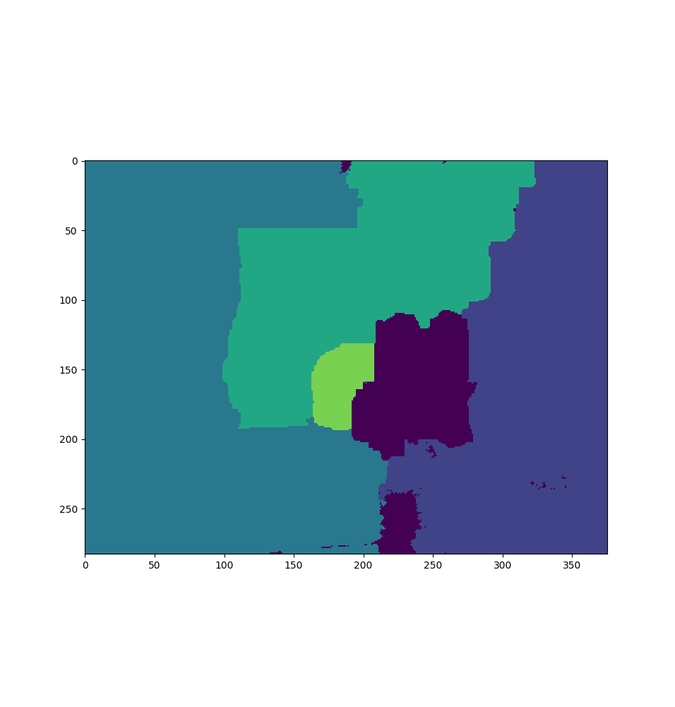В формуле могло быть деление на ноль, так что я изменил её, добавив +1 в знаменатиле. Результат при не особо отличается от первого.

Pano

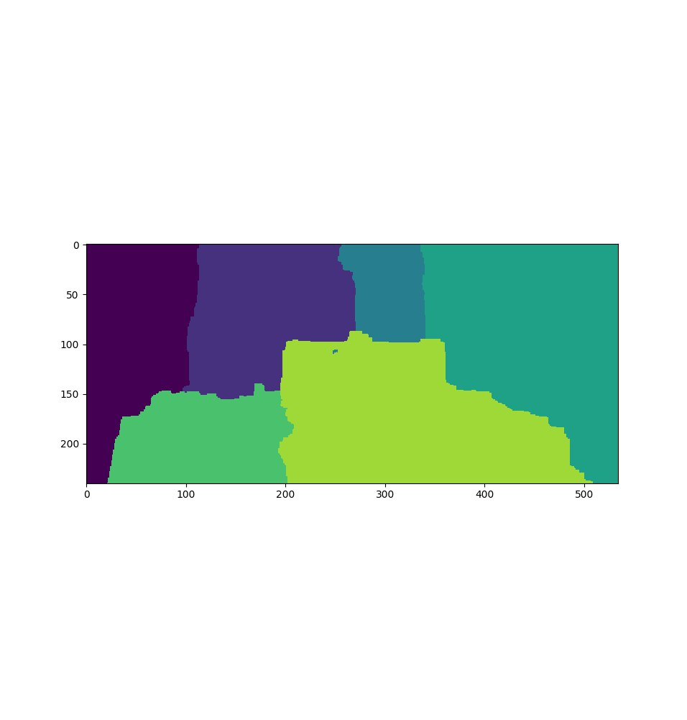Разбиение:

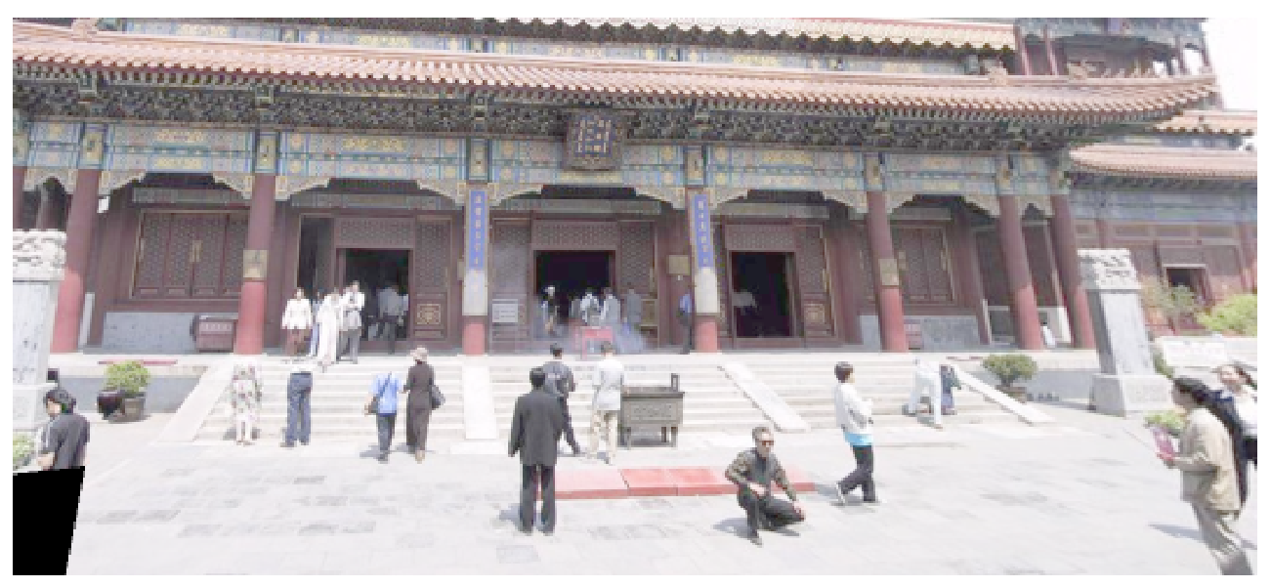Результат:  
  
Результат содержит очевидные артефакты склеивания – “обрезанных” людей на леснице. При альтернативном задании и все становится только хуже.

Задание 3. Стереозрение.

Код для решения задачи:

|  |
| --- |
| **import** matplotlib.pyplot **as** plt  **import** numpy **as** np  **from** PIL **import** Image  **from** pystruct.utils **import** make_grid_edges  **from** pystruct.inference **import** inference_dispatch  **from** utils **import** my_inference_dispatch  **from** skimage.color **import** rgb2yuv  **import** imageio  **import** visvis **as** vv  T = 1  W = 0.05  SIGMA = 18  K = 15  **def** load_image(filename: str) -> np.ndarray:  img = imageio.imread(filename) *# type: Image.Image*  data = rgb2yuv(img)  **return** data  **def** task3():  n_states = K + 1  image_left = load_image(**'./data/imL.png'**) *# (288, 384, 3)*  image_right = load_image(**'./data/imR.png'**) *# (288, 384, 3)*  **assert** image_left.shape == image_right.shape  height, width, _ = image_left.shape *# (288, 384, 3)*  cutted_width = width - K  unary_potentials = np.zeros( shape=(height, cutted_width, n_states))  **for** x **in** range(cutted_width):  **for** y **in** range(height):  **for** state **in** range(n_states):  diff = image_left[y, x + state] - image_right[y, x]  unary_potentials[y, x, state] = min(np.linalg.norm(diff), SIGMA)    edges = make_grid_edges(unary_potentials) *# (212462, 2)*  pairwise_potentials = np.zeros(shape=(n_states, n_states))  **for** state_1 **in** range(n_states):  **for** state_2 **in** range(n_states):  pairwise_potentials[state_1, state_2] = W*min(abs(state_1 - state_2), T)    *# QPBO because max-product works slow.*  result = inference_dispatch(-unary_potentials, -pairwise_potentials, edges, inference_method=**'qpbo'**)    picture = result.reshape(height, cutted_width)  plt.imshow(picture, vmin=0, vmax=n_states, cmap=**'gray'**)  plt.show()  **if** __name__ == **'__main__'**:  task3() |

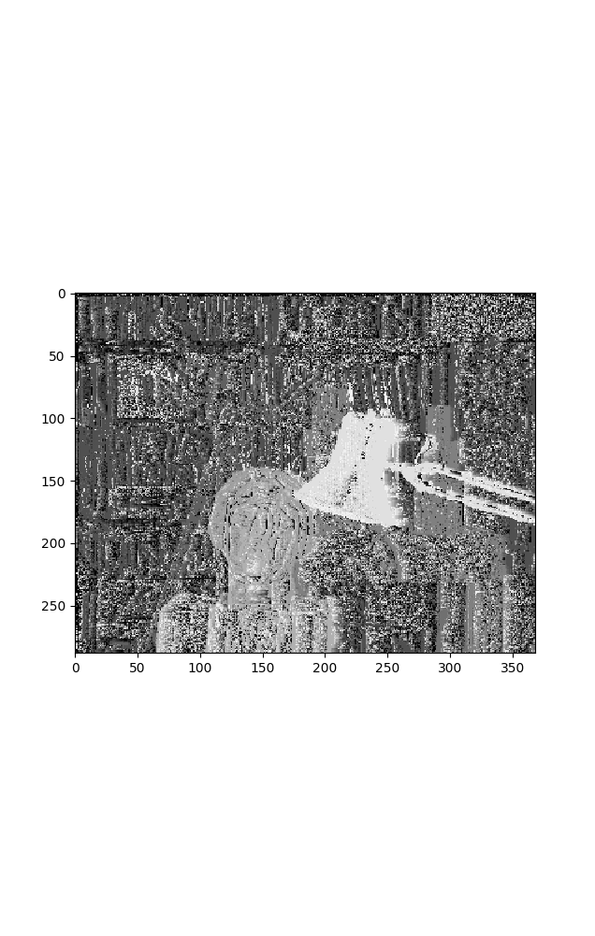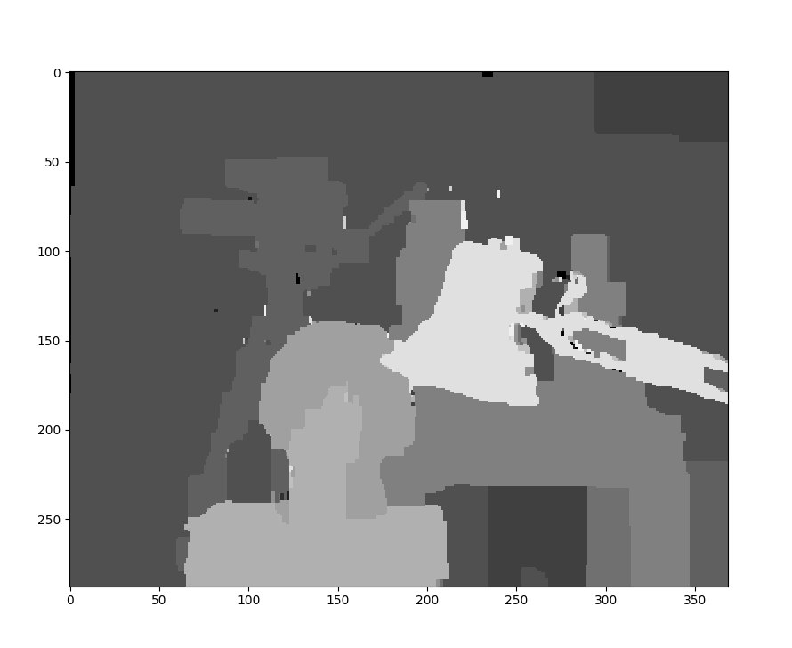Результат для = 15: , , со всеми связям  
Результат только с унарными потенциалами: